User Acceptance Testing (UAT)
Date | 30 September 2026
Team ID | SWTID – 2026-2843
Project Name | AI – Weather Wise API
Maximum Marks | 4 marks

Project Overview:
Project Name:
weather-wise API
Project Description:
weather-wise API provided accurate and location-based weather information, including current weather conditions, temperature, humidity, rainfall probability, wind details, forecasts, and weather alerts.
Project Version:
Version 1.0
Testing Period:
01/09/2026 to 30/09/2026
Testing Scope:
- Tested current weather information.
- Tested location-based weather search.
- Tested temperature and humidity data.
- Tested rainfall probability and weather forecasts.
- Tested wind speed and direction.
- Tested weather alerts and warnings.
- Tested API response accuracy and reliability.
- Tested error handling for invalid locations and requests.
- Tested API response time and performance.
Testing Environment:
URL/Location:
weather-wise API endpoint / API testing environment
Credentials (if required):
API Key / Authentication credentials.

Test Cases:
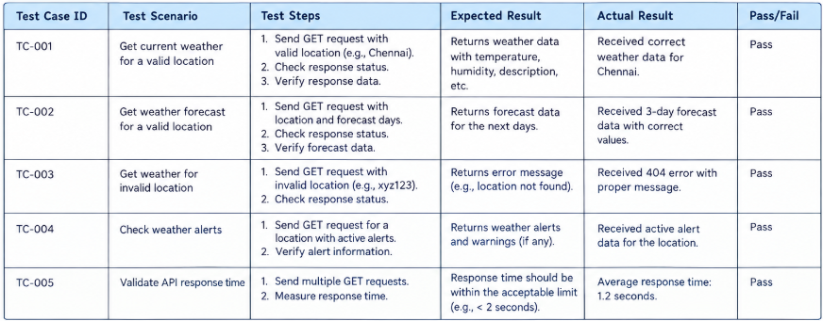
Bug Tracking:
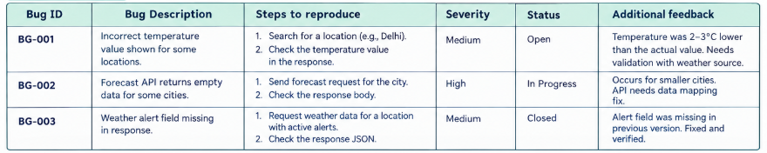
Sign-off:

Tester Name: Ai Weather Wise Api
Date: 30 September 2026
Signature: [Tester's Signature]

scenarios. Notes:

- Ensured that all weather-wise API test cases covered both positive and negative weather
- Tested current weather, location-based forecasts, temperature, humidity, rainfall probability, wind information, and weather alerts.
- Recorded detailed tester feedback, including issues and suggestions for improving the weather-wise API.
- Documented bugs with their severity, status, and steps to reproduce.
- Verified API response accuracy, reliability, error handling, and response time.
- Obtained sign-off from the project manager and product owner before deployment.

